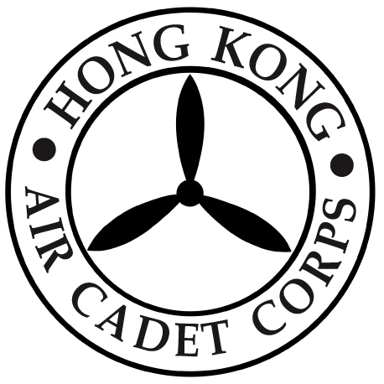

HONG KONG AIR CADET CORPS

From : HQ  Ref : GR19_008 | To : Unit Commanders  Cc : Major Unit Commanders
Tel : 2712 8900  Fax : 2715 6944 | Date:21 August 2019

HQ Close Early on 13 September 2019

Please be informed that Headquarters office will be closed early at 1300 hrs on Mid-Autumn Festival (13 September 2019).

Should you have any enquiries, please contact HQ staff by phone at 27128900 or by email via hq@aircadets.org.hk .

Megan TIN
Administrative Manager

